Case 19-AM,C-Taino-Cer-Bowl-Two Boars

6 1/2 from head to head,3 inches high on the head,2 5/8 inches high in the middle....

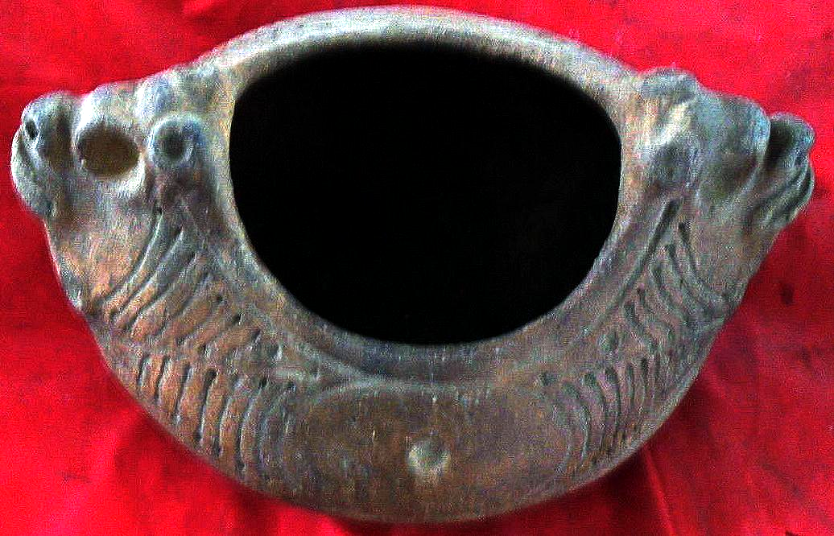

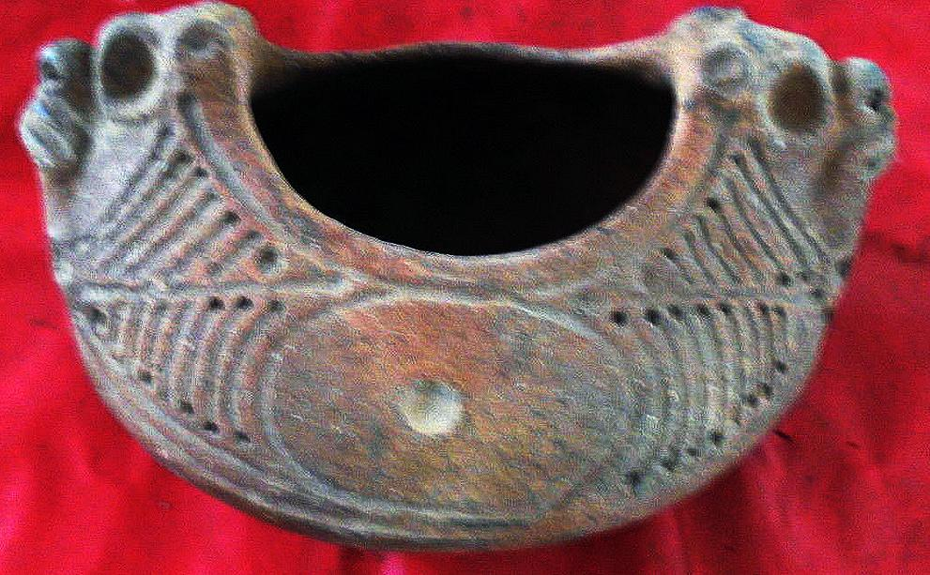

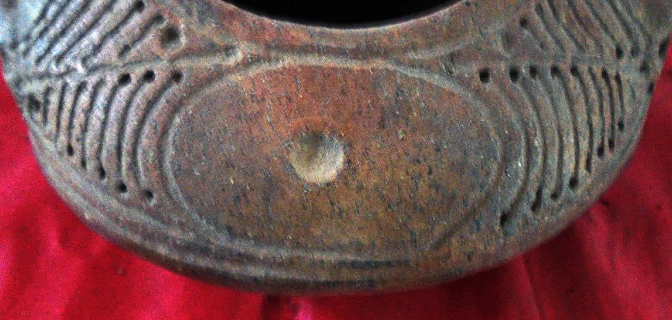

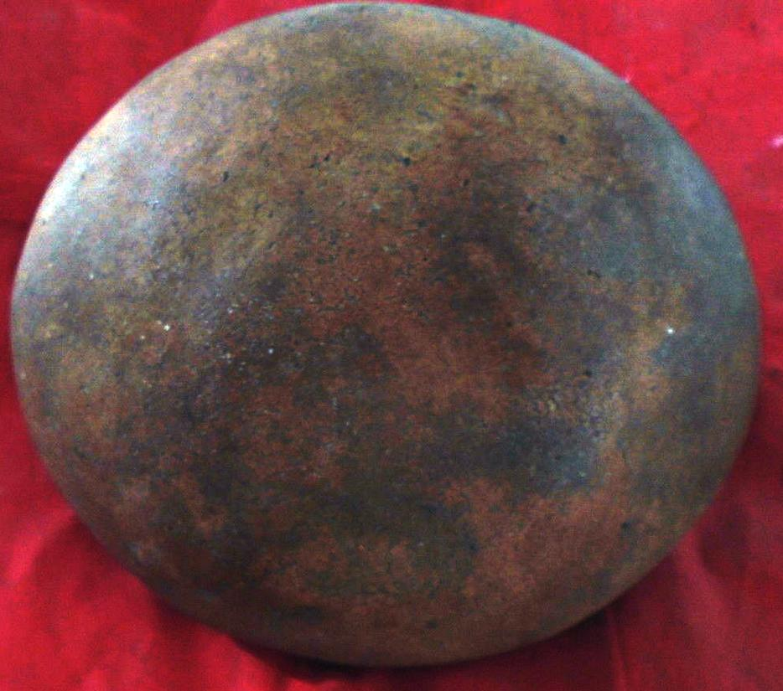

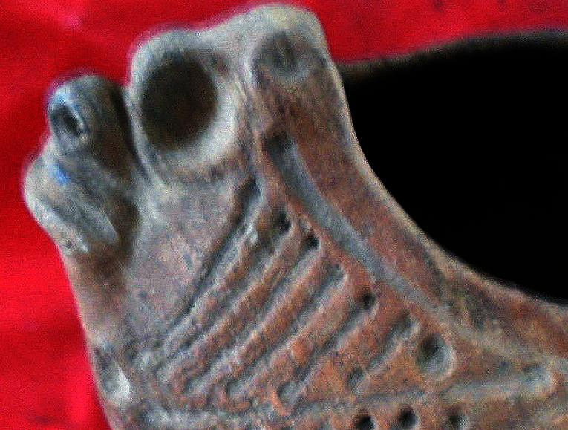

# Order details

## Sales order

Sold by [guayacanex](http://myworld.ebay.com/guayacanex) ( [488](http://feedback.ebay.com/ws/eBayISAPI.dll?ViewFeedback&userid=guayacanex) )

### Delivery package 1 of 1

Estimated delivery Thursday, Feb 25, 2016 - Monday, Mar 14, 2016

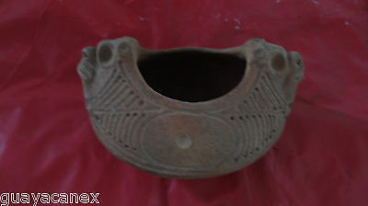

#### [Taino clay bowl with special details](http://www.ebay.com/itm/231799436362)

|  |  |
| --- | --- |
| Item price | $299.00 |
| Quantity | 1 |
| Item number | 231799436362 |
| Shipping service | Economy Shipping |

## Shipping address

Ralph J Coffman Jr

149 Atlantic Ave

Swampscott MA 01907-2427

United States

## Order total

|  |  |
| --- | --- |
| Subtotal | $299.00 |
| Shipping | Free |

**Total**$299.00